Booth design brief
Stand B4.210 · Rev. B
Noah Fischer · 15 June 2026

Brief to stand builders
Three companies were invited to quote: Messebau Kranz (Hamburg), Expo Nord (Bremen) and Standwerk (Hannover). Award to Messebau Kranz on 12 March 2026.

Design principles
- Open and inviting – no closed walls to aisle 21
- Brand colours: Deep Sea walls, light oak floor, teal accents, Sun only on the counter edge
- Hero object: 1:100 turbine model of the Halden HTS-12 on its monopile, at eye level
- LED wall 4.4 × 2.5 m for the Powering the North loop and the live monopile counter
- Two meeting rooms (6 and 4 seats) with acoustic curtains, lounge for 8
- Re-usable modular system – the stand should work again in 2027

Sustainability requirements
- No carpet – re-usable oak-look flooring
- LED lighting only, total connected load ≤ 9 kW
- Print on recyclable textile frames, no PVC banners
- Plants rented, not bought
- Catering without single-use plastics

Renderings
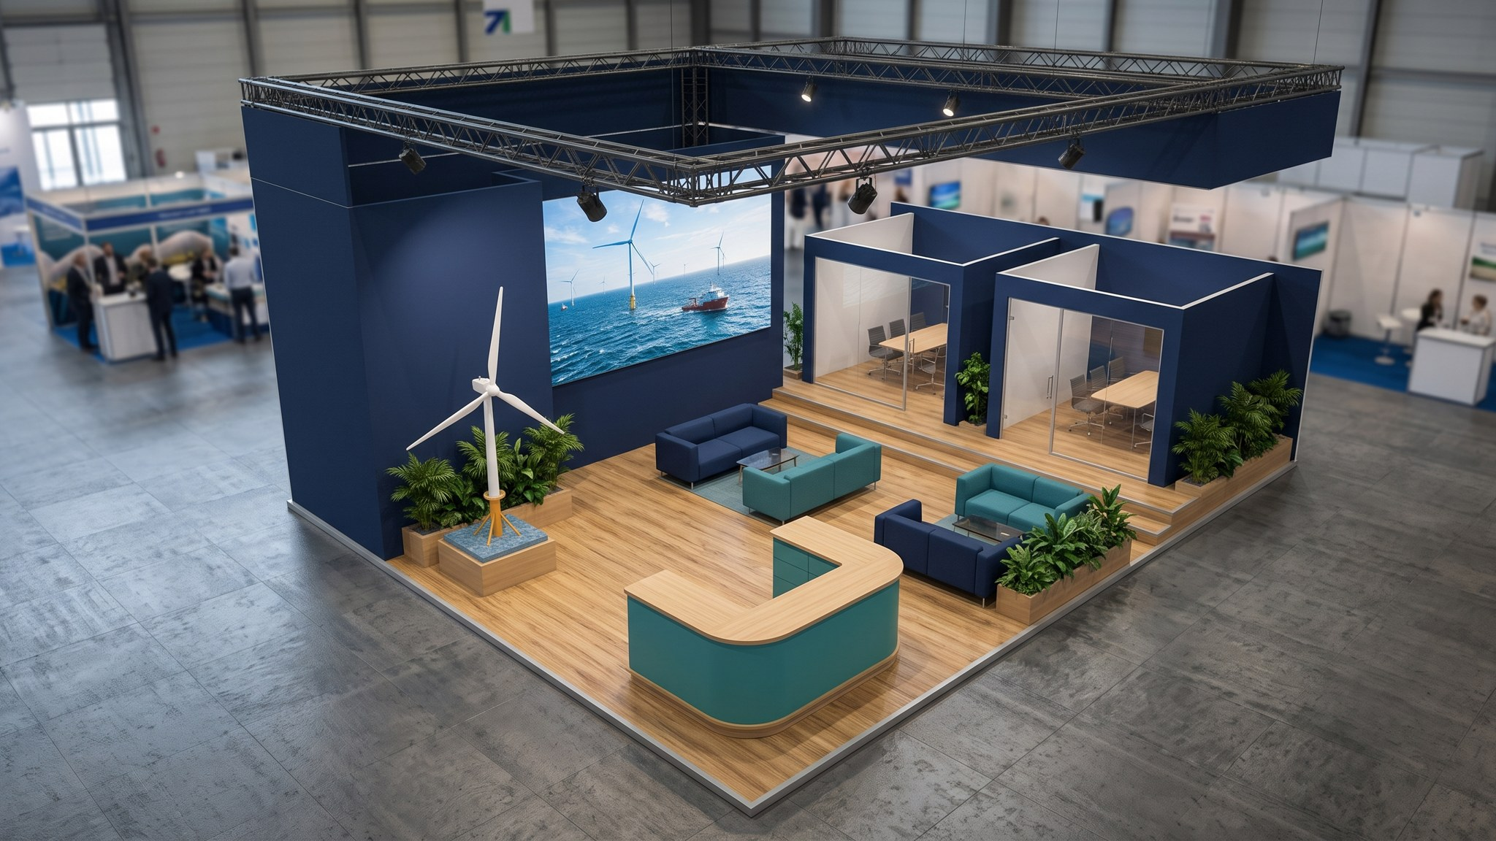
Rev. B – aerial view.
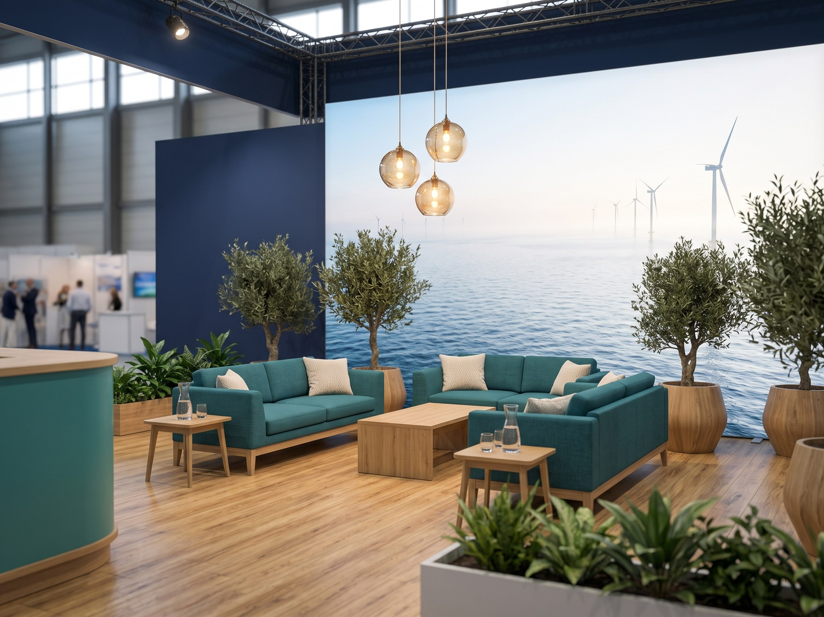
Rev. B – lounge.

